# CCET 3680 Mill Lesson 2 Second Exercise

I. Wireframe:

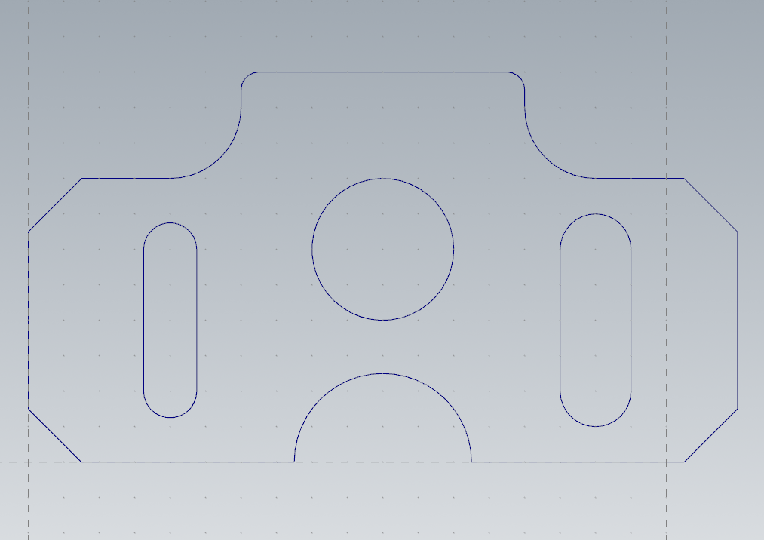

II. Dimensions:

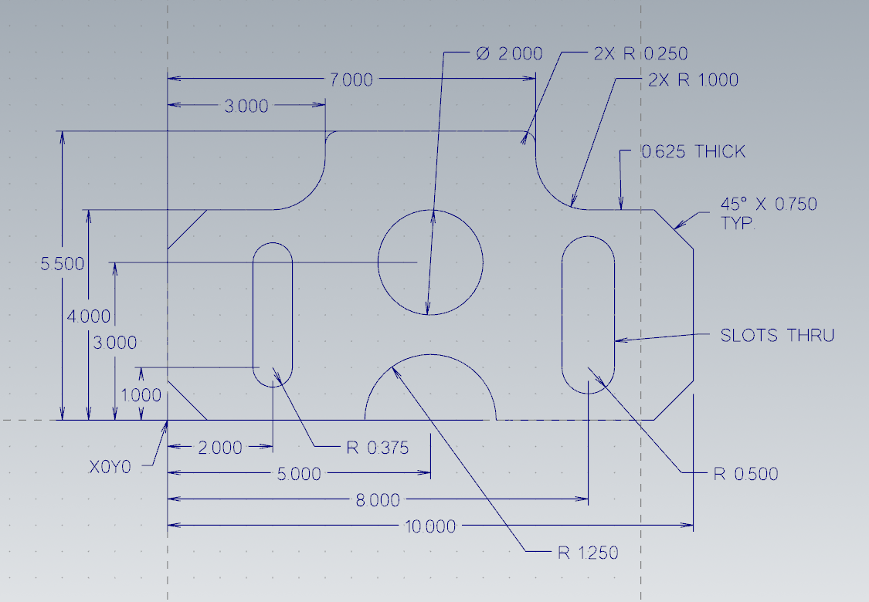

III. Solid:

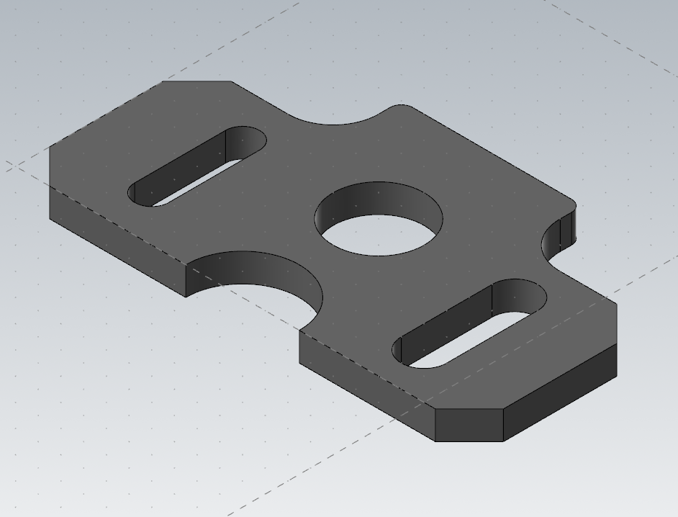

IV. Method:

For this one I set my grid spacing to be 0.5 inches and turned on snapping so I could quickly draw the perimeter with lines. I then offset construction lines for the two slots and then the hole and radius. After this I added the chamfers and fillets, then dimensioned it all.